Networking Notes

* **Networking** means two ormore devises/computer are connected through internet to share data,file and resources.
* **Examples**
* Connect your mobile to laptop via Bluetooth
* Connect printer to wifi
* Online games
* **Note each network has networking but it is not necessary that each networking has internet.**
* **Types of Networking** There are many tipes of networking but we describe just three out of them bcz this types mostly used
* **LAN** stand for local area network. This type cover a small area for sharing e.g house, office, school and computer labs etc.
* **Example**
* In a house all devices are connected through wifi router.
* Bluetooth has short range and used to share files without using internet.
* Mobile connect to laptop to share file via usb cable without internet.
* **Note it is not necessary that you have internet for LAN**
* **Pros**
* Cover small area
* Fast speed
* IP Address is private so it is more secure
* **MAN** stand for Metropolitian area network this is mediam size network connect multiples lan within cities.
* **Example**
* when within city multiple LAN are connected through cable to share data without internet
* **WAN** stand for wide area network means devices are connected through a wide range of location e.g cites, countries and all over the world.
* **Examples in our houses multiple devices are connected to wifi router for sharing this is LAN and this devices use services of servers like you use google , youtube and their servers are located outside the country you access their router though WAN.**

**WAN (Internet / Worldwide Network)**

**internet**

**|**

**-----------------**

**| |**

**MAN (City / Metropolitan Area)**

**---------------------------- ----------------------------**

**| | | | | |**

**LAN1 LAN2 LAN3 LAN4 LAN5 LAN6**

**(Home Office School ... Offices ...)**

* **Entities used in networking**
* ISP
* IP Address
* MAC Address
* PORTS
* PROTOCOLS

**1.ISP** stand for internet service provider this can be a company that provide you internet services for home ,office and mobile devices etc.

* **Example**
* PTCL
* Nayatel
* StormFiber
* Jazz, Zong and Telenor (Mobile Data)
* **Note**
* ISP also provide unique ip to its device when you change ISP your IP address will also change bcz your older ip is not match with other ISP.
* ISP is a company that connect LAN to MAN and then internet(WAN).
* ISP provide only public IP

**2.IP Address** stand for internet protocol Address this is unique device address and it help to identify each device on internet.

* **Example** just like your house address each device has IP address on internet. When you send data from one device to another device the server needs to take address of receiving device.

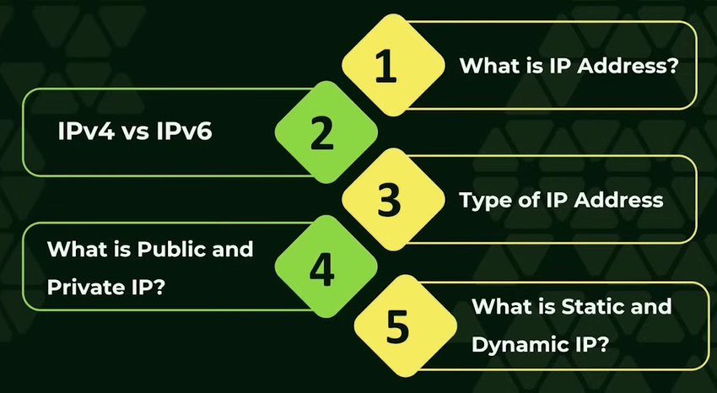

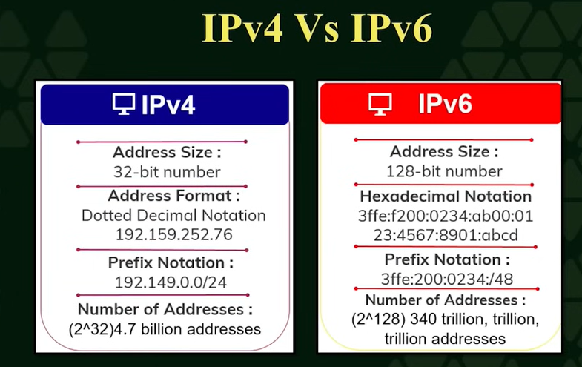

**Range: 0 to 255 Range: 0 to 9 and A to Z**

**IP version 4 IP version 6**

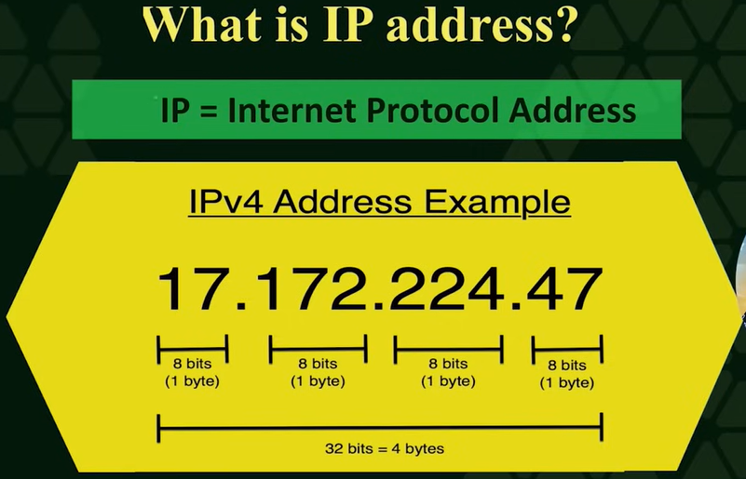

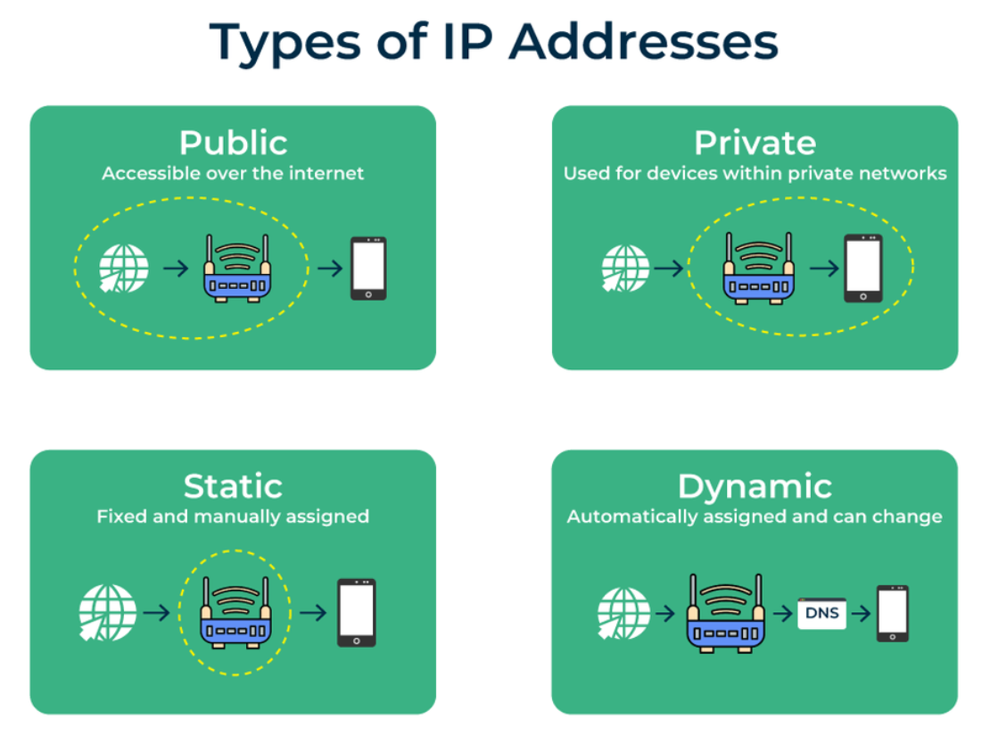

* **Public IP** this IP provide by ISP this IP is directly visible on internet and it helps websites and server to identify you.
* **Example**
* Your House Router IP
* **Private Address**
* is used only on LAN not visible on internet this address assign to your mobile and laptop
* This IP assign by router
* **Example** mobile ,laptop IP
* **Static IP Address**
* Can’t change
* Set manually
* Purchase able
* Mostly used by servers ,cctv and offices
* Always assign by ISP
* Public IP
* **Example**
* Website IP
* **Dynamics IP Address** this address automatically assigned by router or IP and can be changed with the passage of time used for normal house users
* **Example**
* Mobile data IP
* **Note** ISP gives IP to router that is public and router assign IP to your mobile and other devices at home and office that is private IP

**3. Mac Address** stand for media access control this address gives by manufacturer to each physical device

* 12 hexadecimal Address
* Range A to F
* Work on data link layer
* Not directly visible on internet
* Used within LAN
* Mostly can’t change but spoof by software

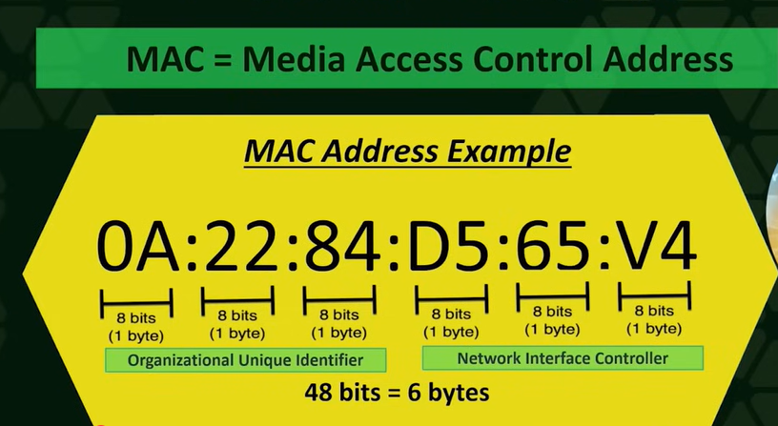

**4. Ports** are logical numbers that tell which device application or service will receive and send the data.

**Key points**

* IP= house address
* Port=house room no
* Range = 0 to 65535
* **Types of port**
* **Well-Known Ports (0–1023)**

**Common services:**

* **80** → HTTP
* **443** → HTTPS
* **22** → SSH
* **21** → FTP
* **25** → SMTP
* **53** → DNS

### ****Registered Ports (1024–49151)****

* Applications ke liye reserved
* **Example:**
* **3306** → MySQL
* **3389** → RDP
* **8080** → Alternative HTTP
* **Dynamic / Ephemeral / private Ports (49152–65535)**
* Temprary ports
* Used on cliend side
* OS choose port when browser open
* Each tab use port
* Ports help to open multiple tabs at same time
* When browser close data transfer complete OS free the port and port pull
* **TCP** Port stand for Transmission control logical no that tell which tcp port or application will receive data
* Client send request of connection to server a connectionestablish data transfer in order
* **UDP stand for user data gram protocol**
* No connection establich
* No ack
* No hand shak
* Packet send directly
* Fast that TCP
* No packet retransmission is packet lost

**5. Network Protocols**

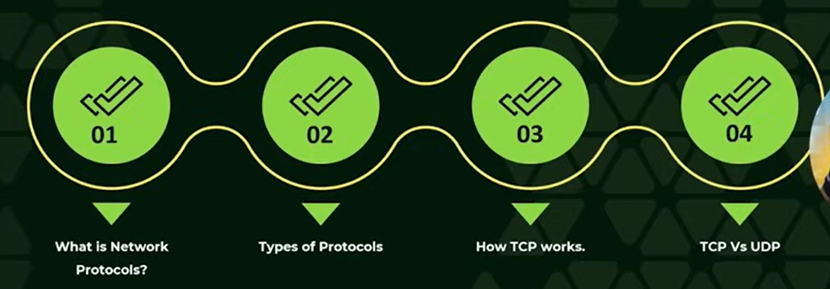

* **Network Protocols are rules that helps a computer or device to communicate over internet.**

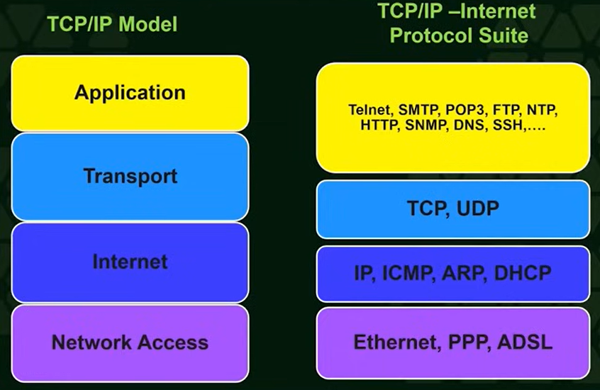

* **TCP stand for transmission protocols**
* Use three way hand shake method
* Core communication protocol
* Work at transport layer protocol
* **UDP stand for user datagram protocols**
* No use three way communication method
* Core communication protocol
* Work at transport layer

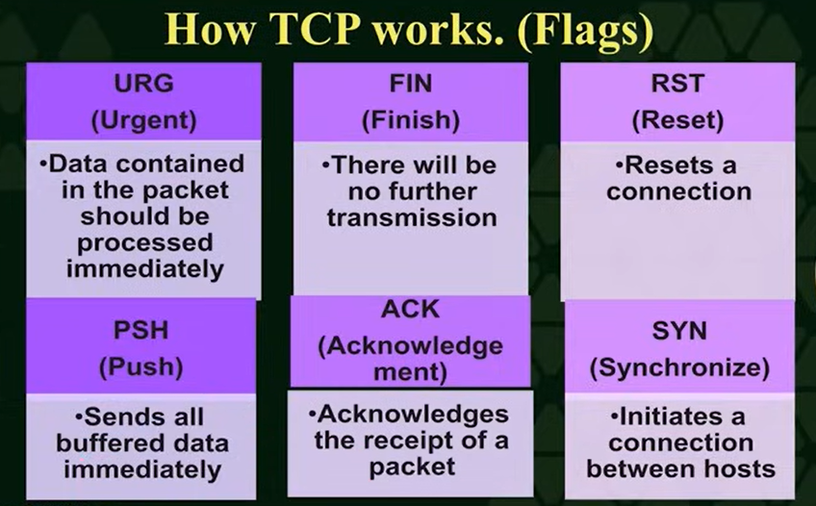

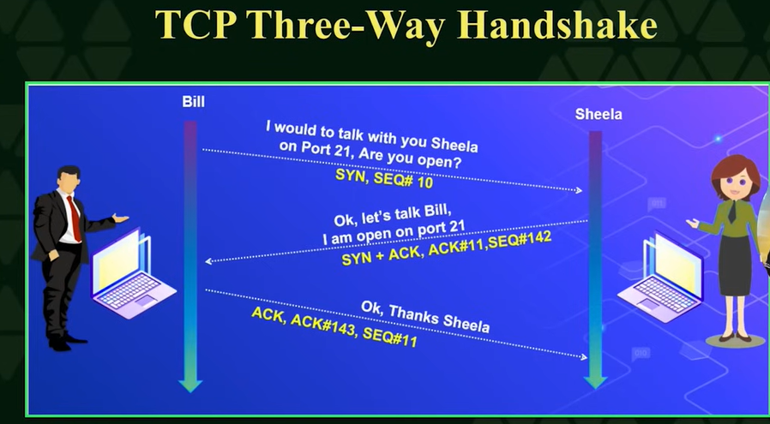

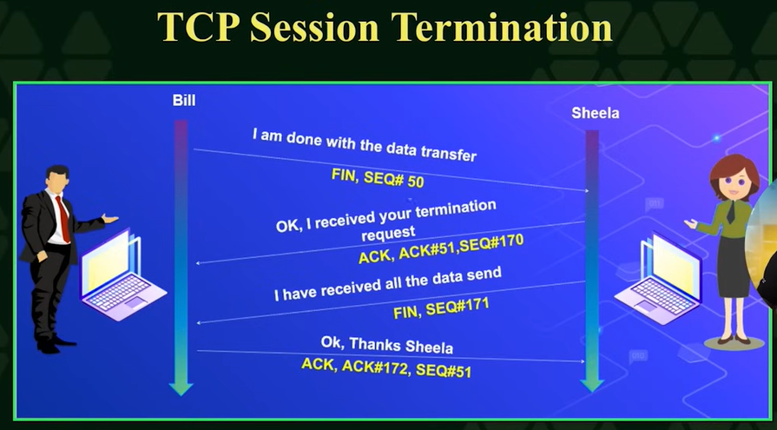

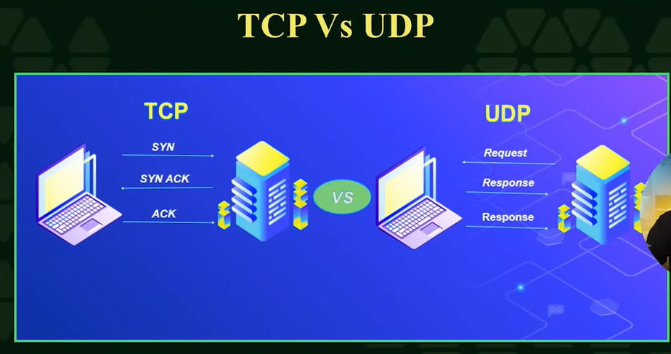

* **Router** is a device that give internet access to multiple devices at home, office etc like laptop ,mobile, pc.

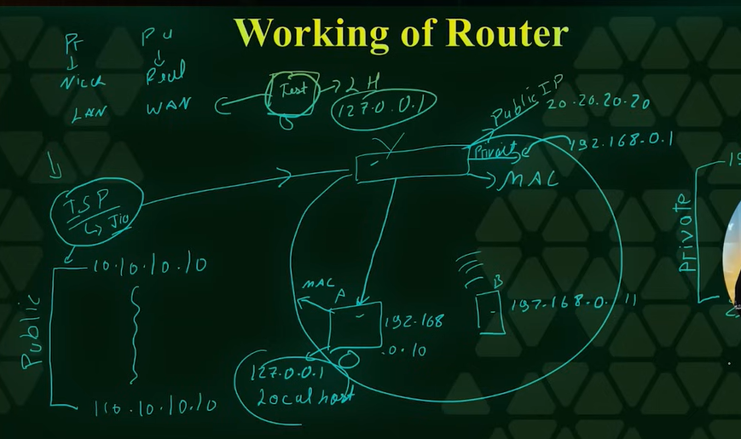

* Router has public IP from ISP and gives Private IP to other devices.
* Router has also private IP to talk with other devices that have Private IP.
* The same IP is needed to talk between devices.
* Each device has local host IP to talk and process its self resources. This is same in every device 127.0.0.1.
* Each device has Mac address during its manufacturing.
* **How router give IP address to devices?**
* **There are two way**

**1. Manual** In manual we go to router setting and then add IP address for each devices.

**2. Automation** In automation IP address assign automatically with DHCP ( Dynamic Host Configuration Protocol) and it get help by ARP(Address Resolution Protocol)

* **ARP** (Address Resolution Protocol) help to find the IP address of system.

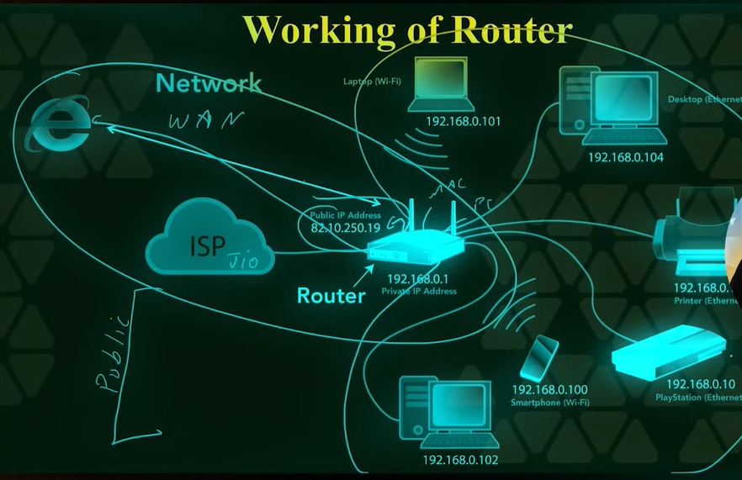

* **HTTP (Hyper Text Transfer Protocol)**
* It is rule used to communicate with server through browser(client)
* **Request main parts:**
* **Method**
* **GET → Get data**
* **POST → send data**
* **PUT → data update**
* **DELETE → data delete**
* **Example:**

Facebook login

* Username + password → **HTTP POST Request**
* **HTTP Response**
* After getting request server give response to client
* **Response ke parts:**

**Status Code** – result   
 **Headers** – server info  
 **Body** – webpage / data

## Common HTTP Status Codes:

* **200 OK** → All Right
* **301 / 302** → Redirect
* **400 Bad Request** → Wrong request
* **401 Unauthorized** → login required
* **403 Forbidden** → access denied
* **404 Not Found** → page not found
* **500 Internal Server Error** → server problem

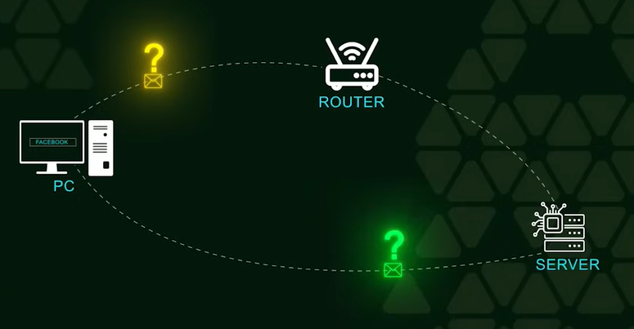

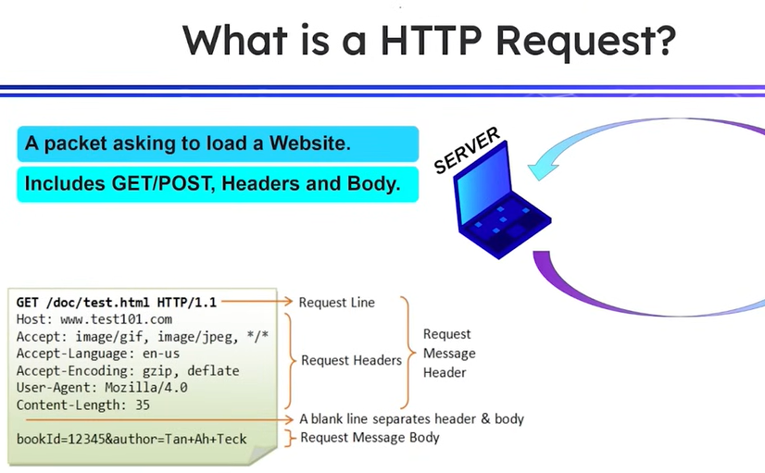

* **HTTP (Hyper Text Transfer Protocol) is used when you talk with websites/ access any website**
* **Rules**
* **When HTTP send a packet to server it is called Request**

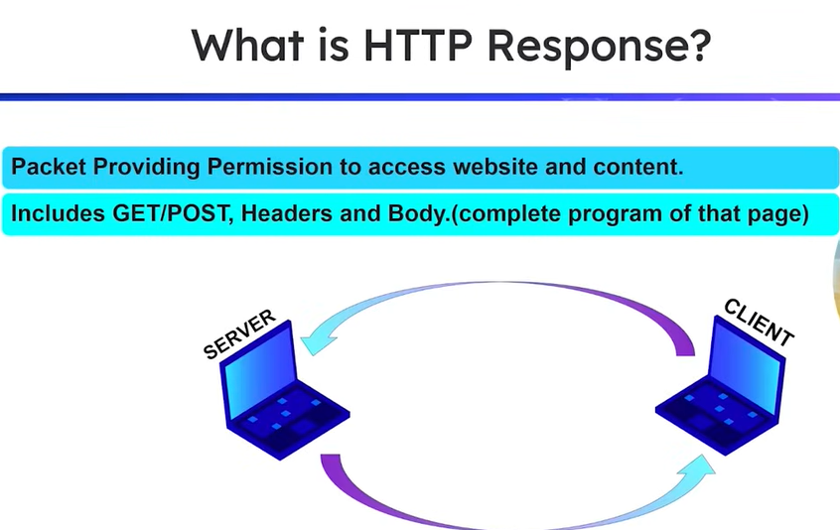

* **Types of Request Method**
* **GET**
* Data transfer through URL easily visible not secure.
* **POST**
* Send user information & file in body, secure using html form.
* **PUT**
* Dangerous method because the hacker can replace all current representations of target resource with uploaded content.
* **DELETE**
* Dangerous method remove all current representation of the target resource given by a URI.
* **OPTIONS**
* Describes the communication for the target resource.
* **TRACE**
* This can be more useful for hackers bcz with help of that method Hacker can find URL or server and then perform other operation like PUT and DELETE.
* **CONNECT**
* Establish a tunnel to the server identified by a given URL.

**DOMAN NAME AND DNS NETWORKING**

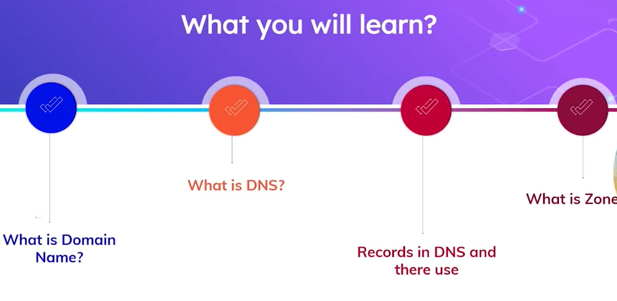

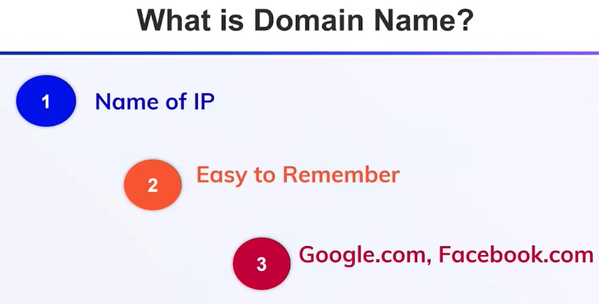

* When a developer make website this can not be accessed by other browser bcz website contain private IP and to access it all over the world it needs to be public IP so Developer purchase the DNS for its website e.g he goes to website and fill the credentials for its website. Then some information of its credentials are store in Zone file .This info is useful when DNS find IP for name server.
* During configuration of website he fields the following fields and zone file updated automatically after some time after records updation.

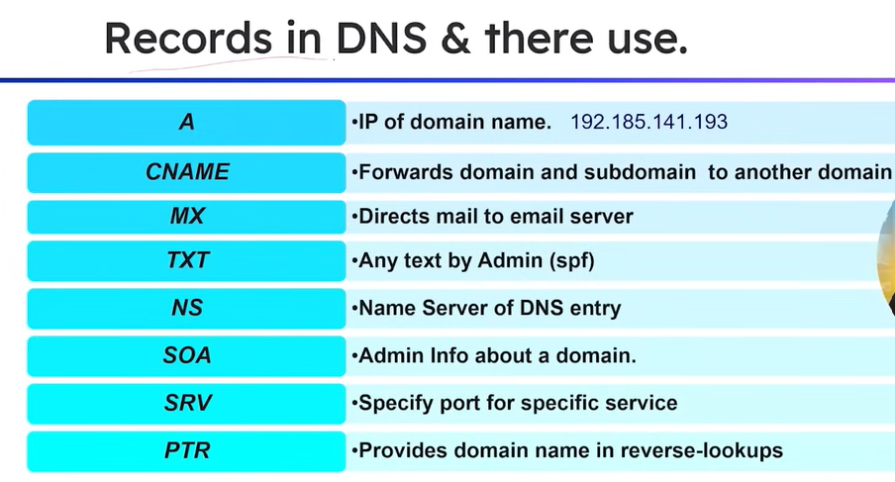

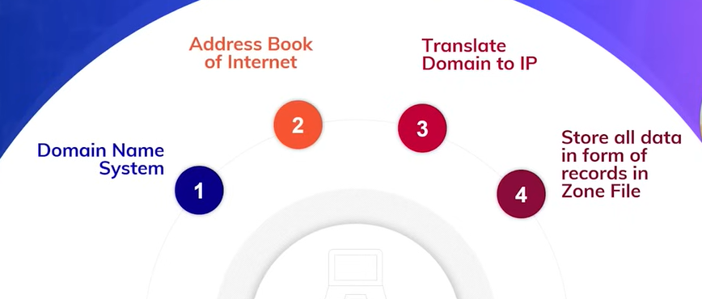

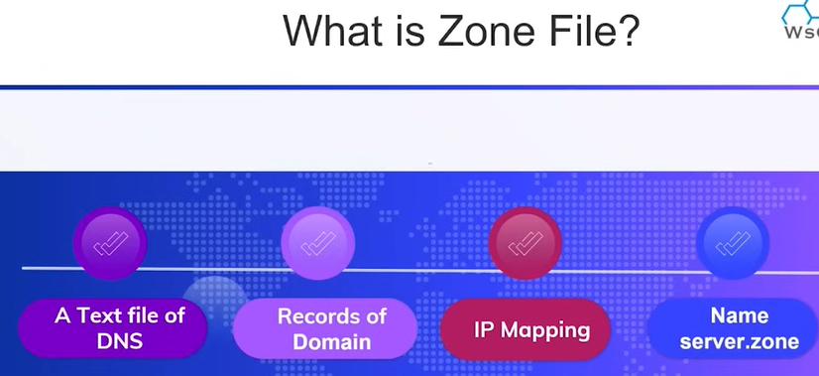

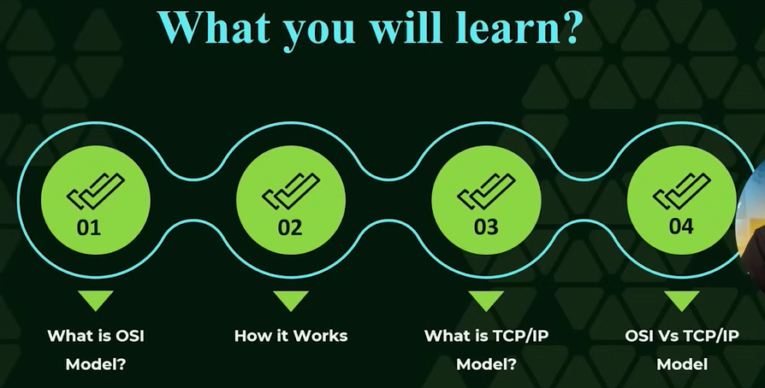

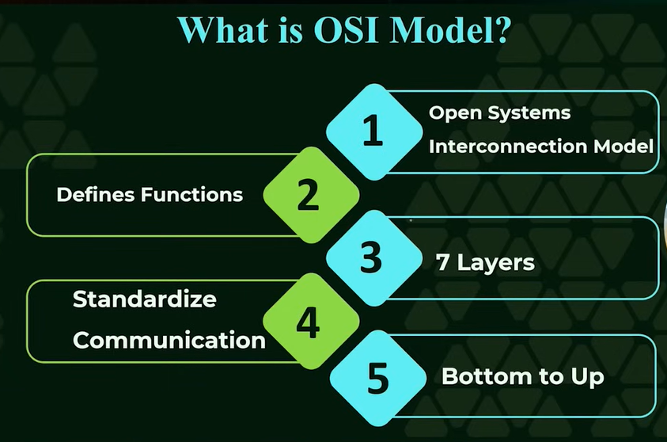

**OSI Model is a method of step by step communication**

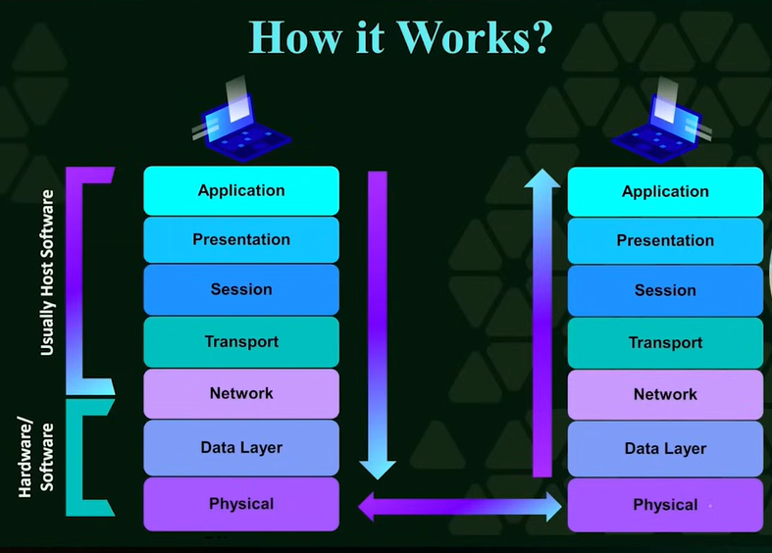

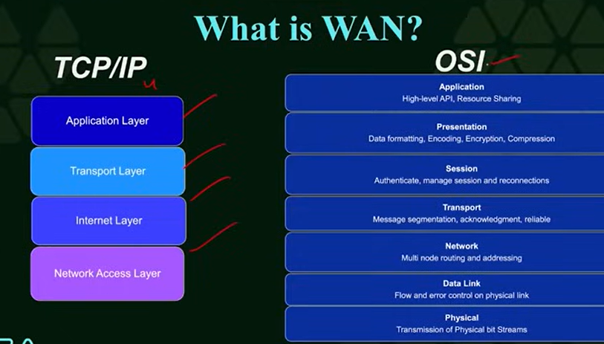

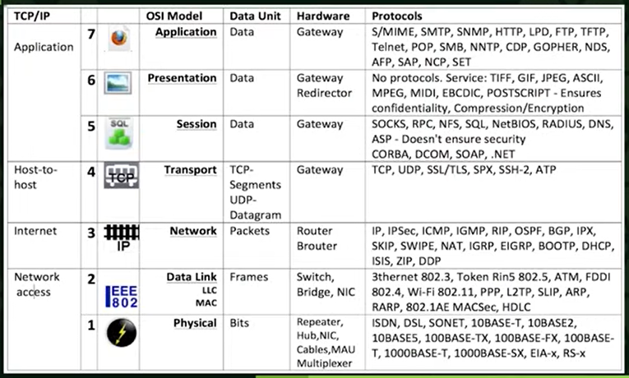



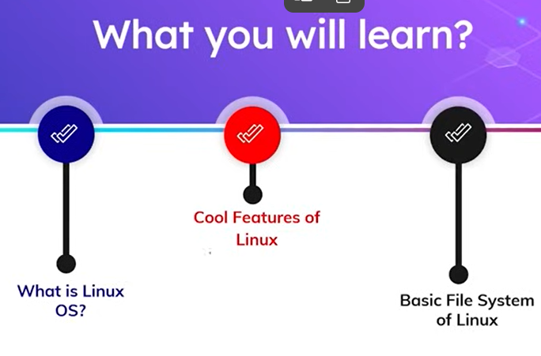

**Linux**

Open source operating system and free to use. Open source code to modify you can change/modify and see code according to your needs.Based on linux karnel. Kernal means software don,t directl talk with hardware it act as brige between them and help to talk. Developed in Sep 17 1991 **Linux Torvald** and work bycommunity.

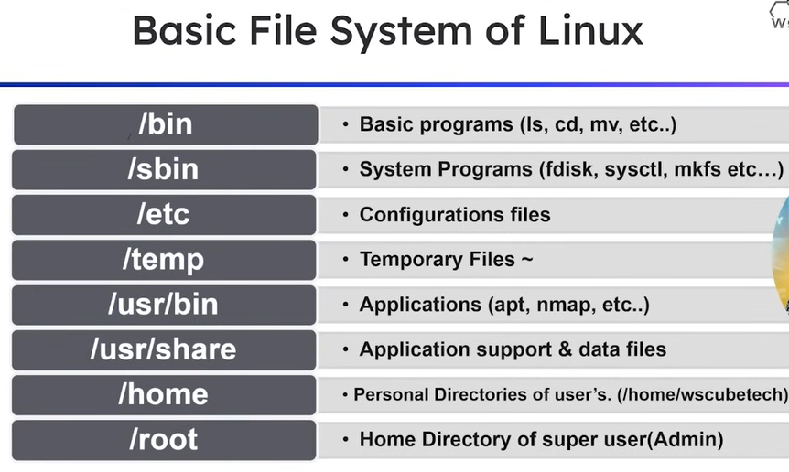

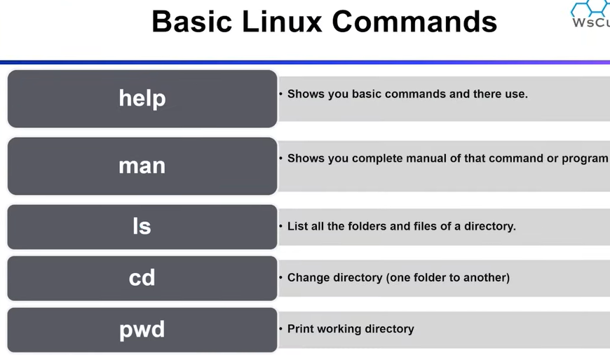

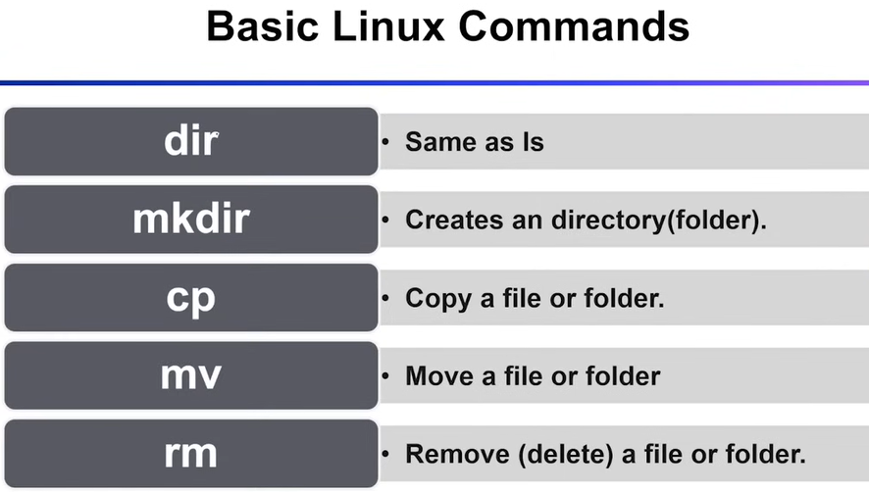

* **dir sport in cmd but ls not**

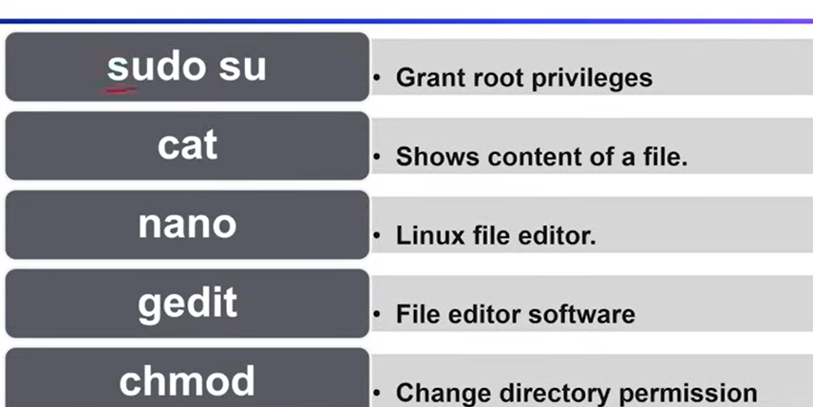

* gedit (Graphical editor)
* chmod (change directory)
* if # show in terminal than there is root permission and if you del file of root that you will be corrupt the root
* if there is $ there will be no permission
* when we create file through Linux it has three permisions it is not necessary that it always has three permissions
* this can be read write and execute show as (r, w, x)
* in Linux first two permission are mostly used but we can used third one also through command
* e.g to execute any file chmod+ (give permission)
* chmod - (permission denied)
* apt is a linux play store with the help of it we can download packages ,del or update
* etc is a folder of root that contain setting / configuration file of any system
* before using apt we need to update it if we not do that than the apt put error like it does not contain that file that you want to update , del, etc
* cd /etc/apt
* to find mac address of any device just go to cmd and type getmac and then past it on website like maclookup
* how to install software at kali Linux
* there are three mathods
* 1 .through play store and in Linux apt
* 2 . Download through a software official website
* 3 . third party software like GitHub but we cannot relay on it compeletly bcz any malicious code can be add by hacker
* **Note**
* before using apt always update apt
* if you want to install any pkg just wirte
* apt install then name of tool
* e.g apt install bytecode-viewer

**Introduction To Apache**

* how server of apache of Linux or window work or any OS work?
* how server work on website hosting in Linux and what tools are used for that which called IIS(internet information service ) in windows it help to make its system as server and find open ports and provide different functions like file sharing and website access and in Linux
* used apachi website hosting ,provide services and information sharing. Apachi is a server that help to open http(hypertext transfer protocol) service at port 80.
* **layers or internet**
* url (uniforn resource locator)also called uri(uniform resource identifier)it can be address of any thing like file ,accest resource at are on internet
* format protocol://hostname[:port][/path]file[?paradrims=value]
* protocol=http or https
* hostname=website name
* port=443
* path=images
* file=logo.png

How to change MAC Address

There are two method to change mac address

1. Automation

2. Manually

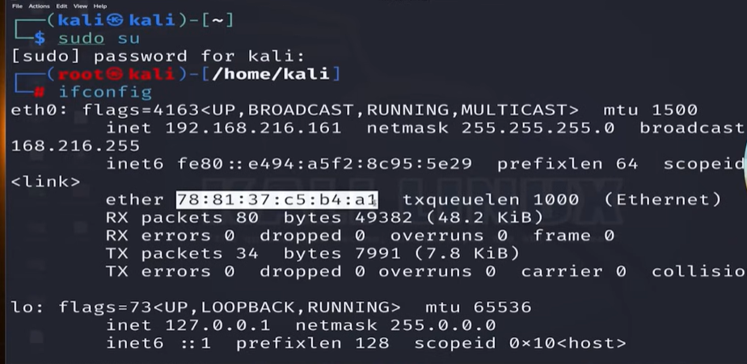

MAC Address that highlight

Manually

When we change in hardware first stop it and than make modifications.

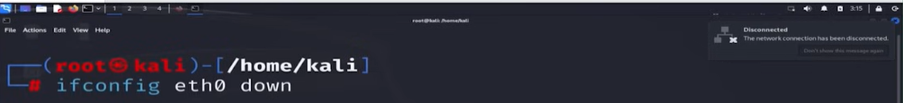

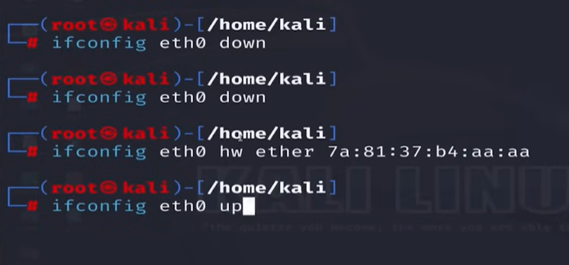

* Ifconfig eth0 up tp start hardware device
* Hw used for hardware

Automatically

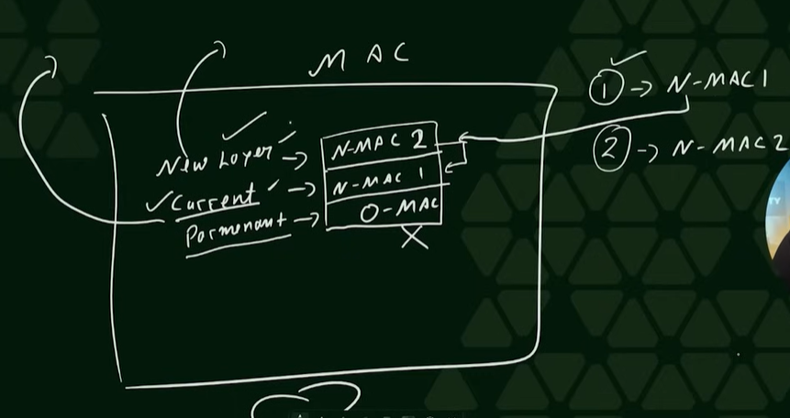

* New layer and current layer mac address are visible to other user but permanent is not

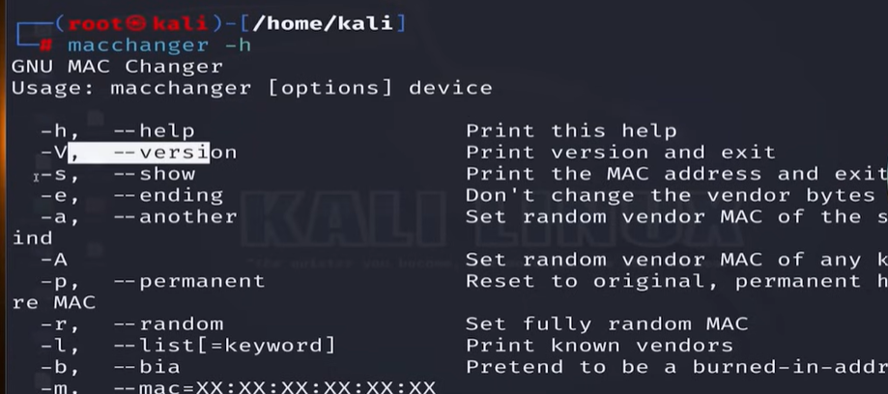

Macchanger -l

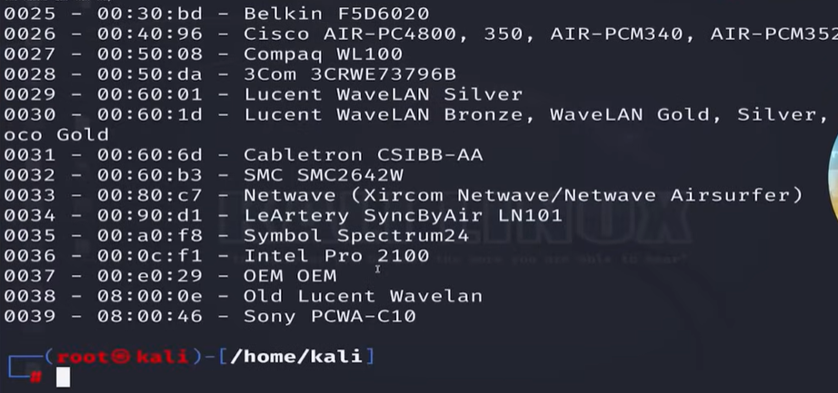

Show all vendors and there first three pair of mac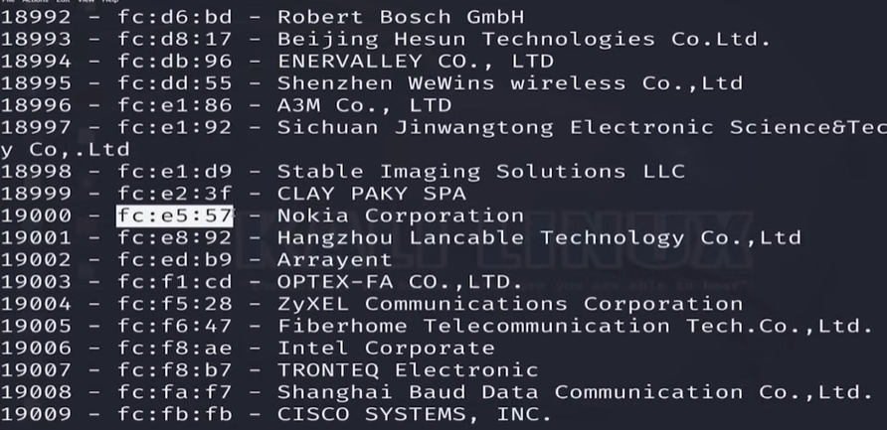

Now you pick mac of any vernder and run this

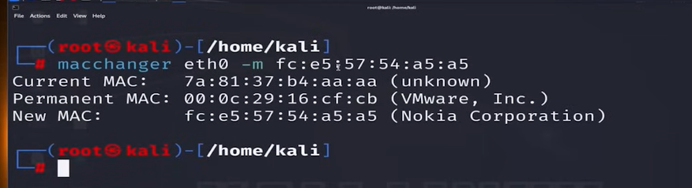

* Etho =device name
* -m= manual
* And change last three digit by your self
* **Note**
* We learn that mac address cannot be changed when we change mac address in new layer and current layer after starting a system /pc ths retake its original mac address.
* To sove that problem we make a program file that helps to change the mac address and if we attach this file to reboot of system then this help to change the mac address when it restart.

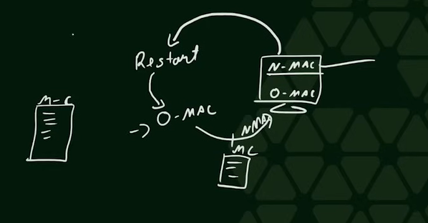

Practically perform that



Make this file

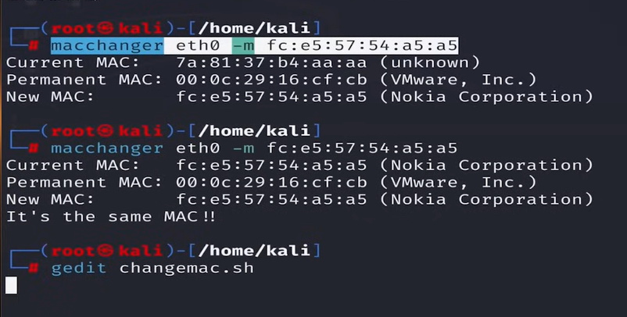

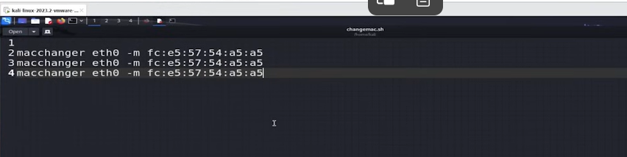

* Past this command three time
* Change new layer
* Change current layer
* Cross validation

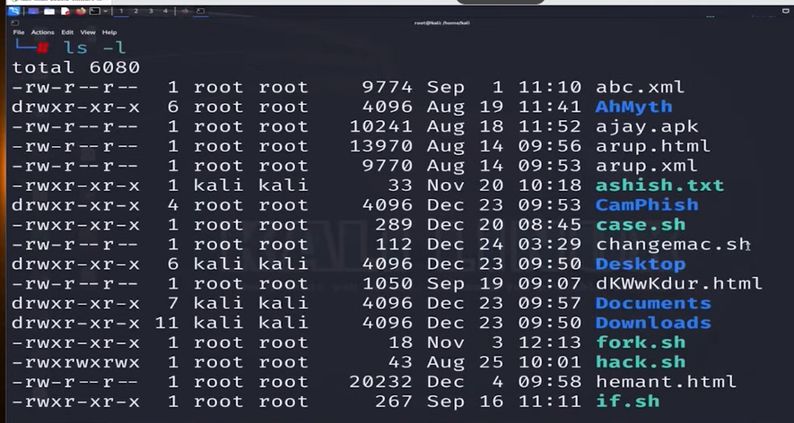

* Changemac.sh file only permission of read and write not execute this file linux make currently and linux did not execution permission to any file by default.
* To give permission use that command

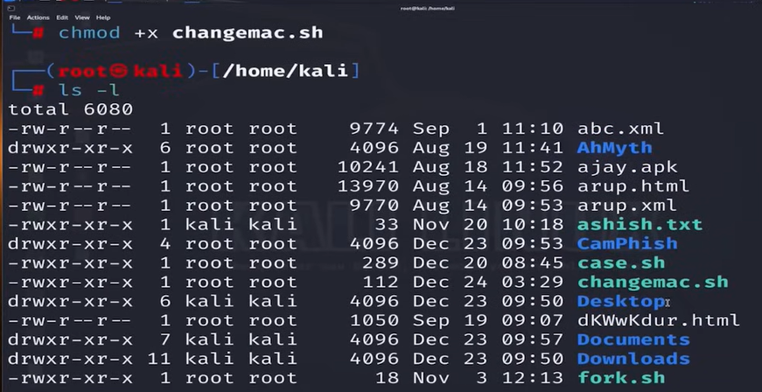

Now this file has three permissions rwx now we can run this file

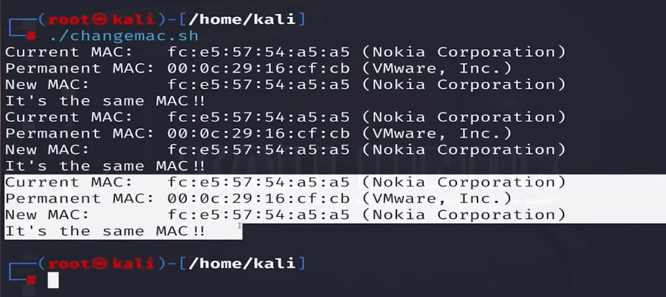

Now this file is running

Steps to run this command with system reboot

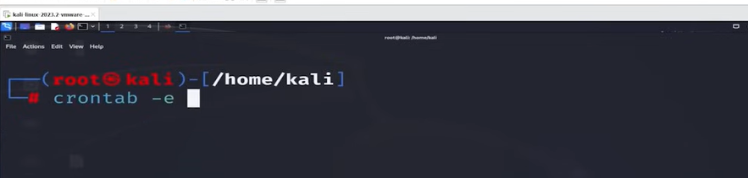

* -e =editing
* Crontab is a tool that we guide we you do first after rebooting of system

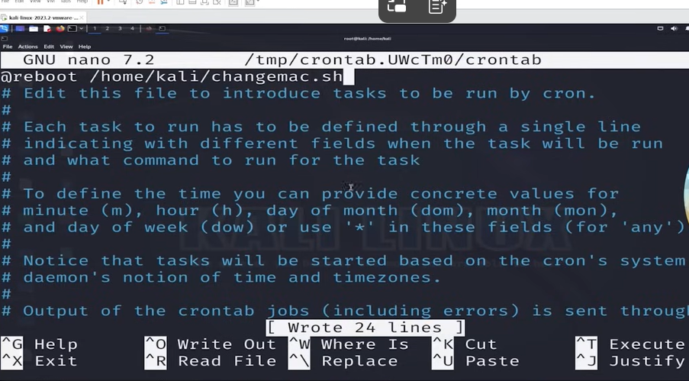

Now make service default bcz it will work with system rebooting

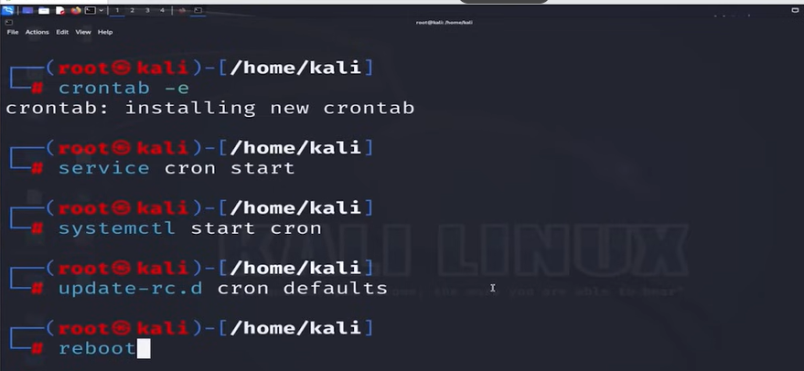

Then reboot the system to see that our crontab is working or not

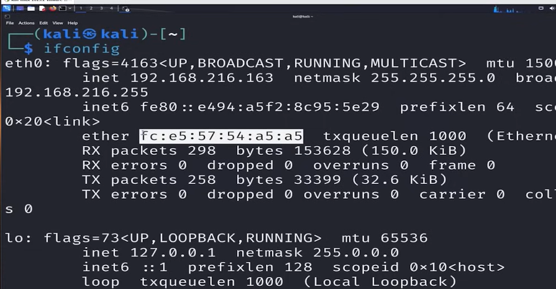



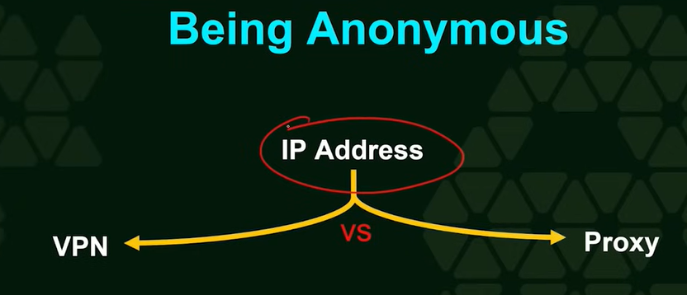

VPN (virtual private network)when user use that it get access to a another device that is virtual and it has public IP when user request for any website like fb that virtual device request to that fb to fb server and fb server give responce to that virtual machine and virtual machine give restponce to that user so the fb server get the IP of that virtual machine not user this help make annomous.

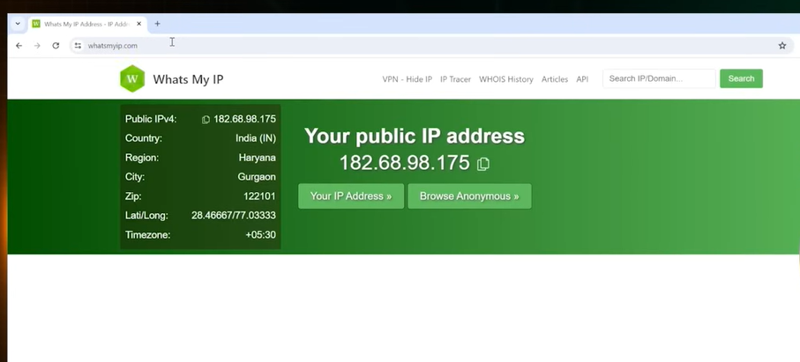

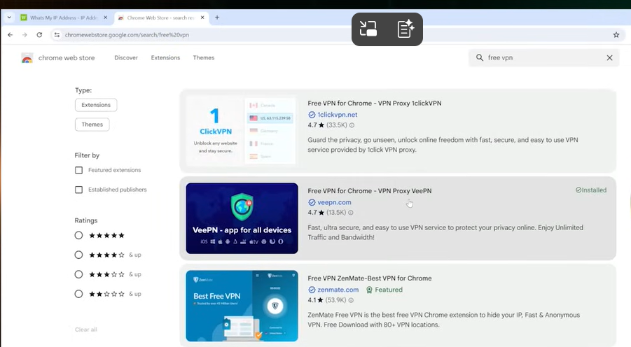

* **VPN Drawback**
* 1 VPN
* DNS Leak
* **Proxy IP (middle)it is a middle IP that work between you and your server.**
* **There are two types of proxy**

1.manually in manually

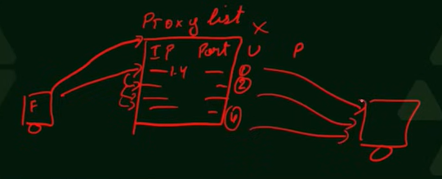

* Multiple IP

2. Automation

* This support Tor software which give three virtual devices betwwn user and server. Tor has its own server called Tails and browser called Tor browser.



* **Def: -**

How devices are connected with each other in a structure

* **Types**
* **Physical**
* Devices physically used to communicate with each other
* **Logical**
* Logically devices are used to communicate with each other
* **Star Topology**

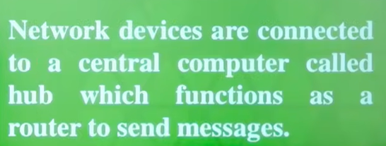

* **From one device to another device**

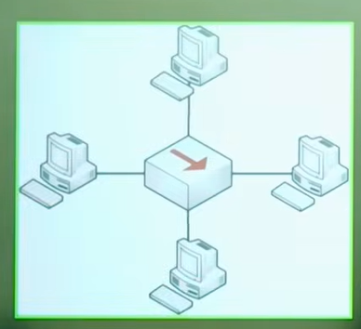

* **Buss Topology**

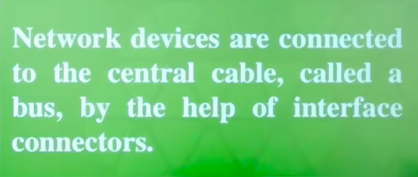

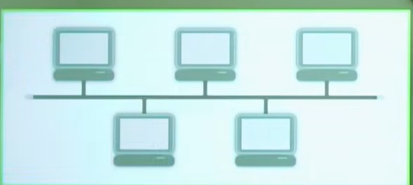

* **Ring Topology**

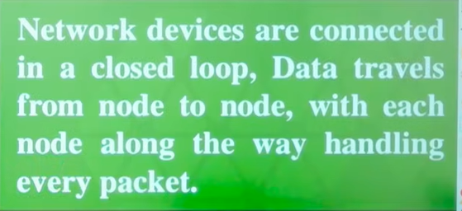

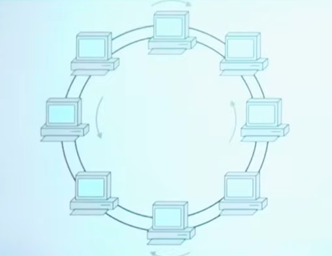

* **Mash Topology**

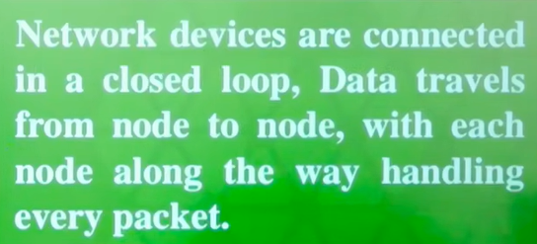

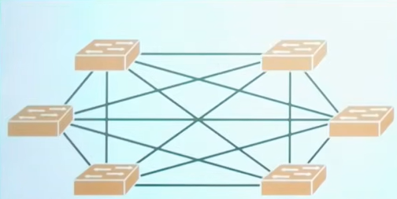

* **Tree Topology**

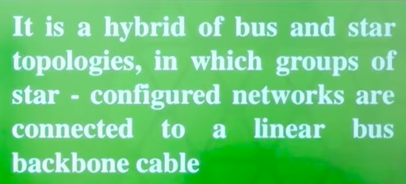

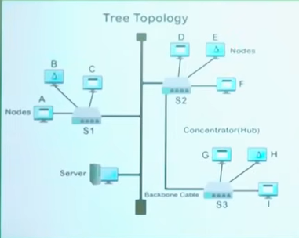

* **Hybrid Topology**



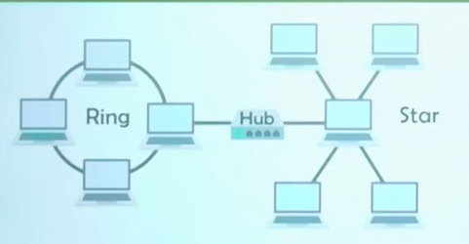



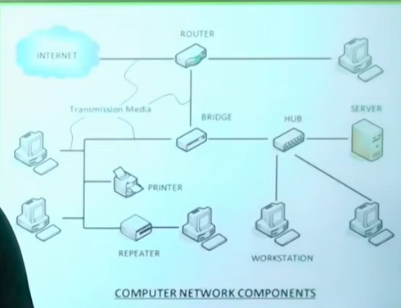



It is a device that allow computer or other devices to communicate over network. It give MAC address to each device which is unique. Without that devices are not able to communicate with other devices. The communication can be wirelessly or wired. Work on data link layer. This can be network plug or network gate. Without that you will not able to use internet services.

* **Example**

SIM card of your mobile you will not able to make calls or network services.

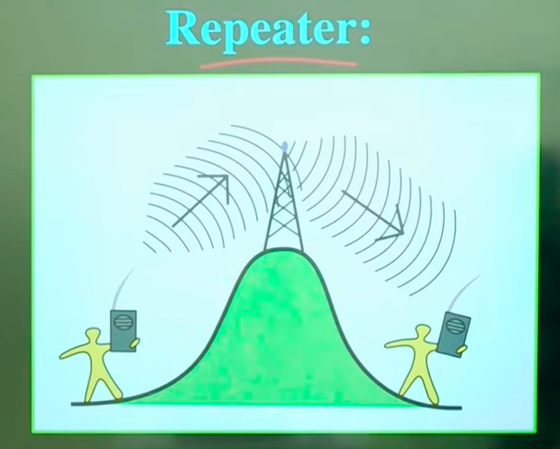

* Repeater is a booster device that git weak signal and make them strong then next move.
* Work on physical layer
* Used for long distance network
* Used to extend WIFI range
* Used to find long distance signal
* **Example**
* Loudspeaker
* Simple Wi-Fi

Router weak signal **Repeater** strong signal Mobile

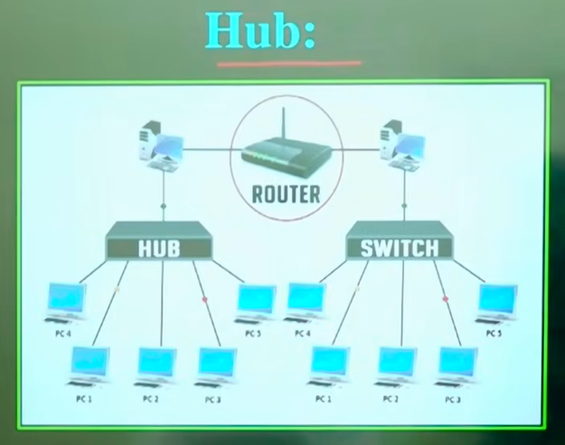

* Hub is a central and broadcast device that help to communicate it send data to all device that attach with it to communicate

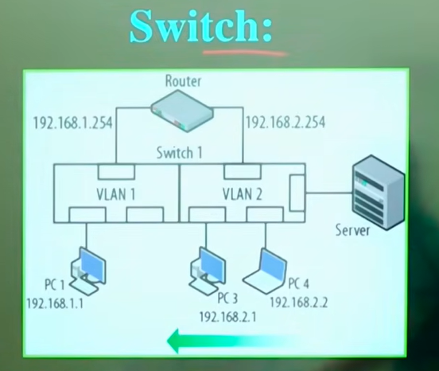

* Switches can be similar to HUB but it can only send data to that particular device that which contain same IP that have switch contain IP to send data.

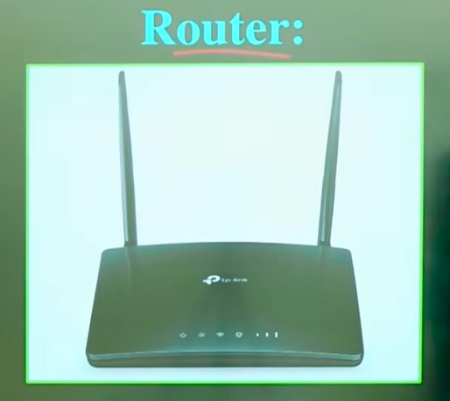

Router is a networking device that connect different network and send data to right route.

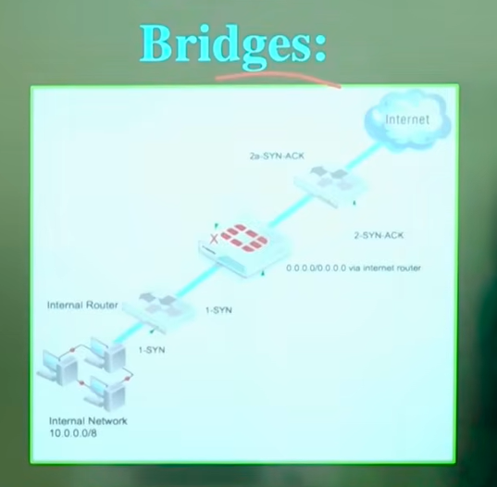

* Bridge is a network device that connect similar network (LAN) device and filter the traffic.
* Just send necessary data
* Use MAC address
* Minimise collisions
* Work on data link layer
* **Example**

Bridge just like gate keeper only authorised people can get permission to move in that particular place.

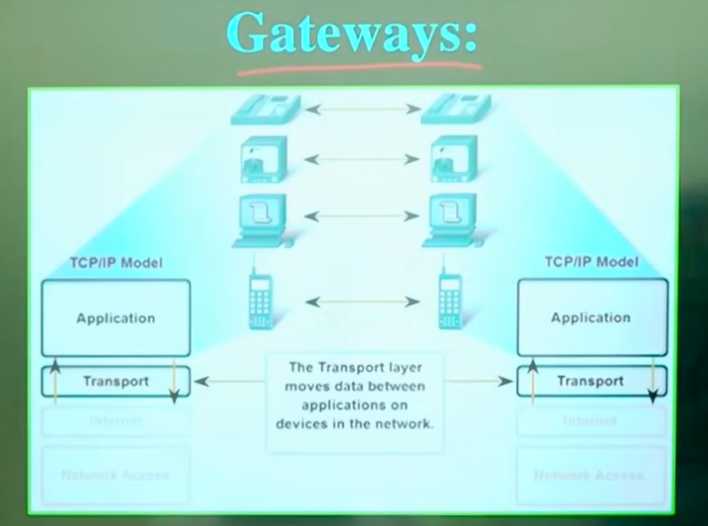

* Gateway is a device from where your local network connect with another network or internet.

**Gateway = network ka exit & entry point**

**Your computer just known your local system like your home and network devices and router but when you use outside system access like google, whatsapp or send data on internet than you need gateway.**



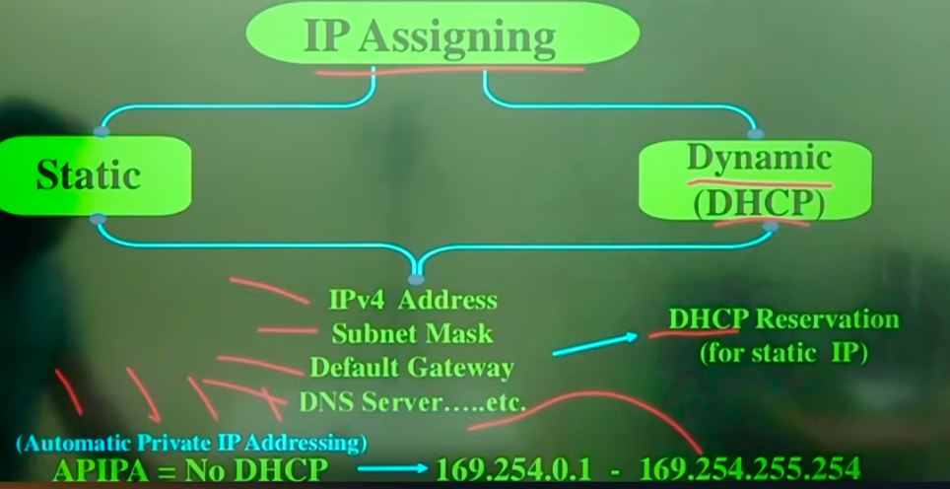

* **As we know that there are four type of IP private/dynamic public/static. If a system has that IP public/static than it can be server. But we talk about dynamic or local IP that IP contain local system.**
* **If we want to switch our private IP to public IP then we take use of DHCP reservation.**
* **Key points of DHCP reservation to switch our private IP to public IP**
* **IPv4 Address**
* **Subnet Mask**
* **Default Gateway**
* **DNS server…etc**
* **After completing that points our system will configure and assign private static IP**
* **APIPA (Automatic private IP Addressing) is used when no DHCP used or working.**
* **It assign some IPs to our system**
* **Disadvantage**
* **Not used internet**
* **No communication**
* **IP range (169.254.0.1 to 196.254.255.254)**

**Special IP Addresses**

**1.Lookup Address**

* **127.0.0.1 - 127.255.255.254**
* **Assign to local systems**

**2. Reserved Address**

**240.0.0.1 - 254.255.255.254**

**3. Virtual Address**

* **Not Associated with physical network adapter**
* **Used in virtual machines, internal router address**
* **All IPs that Assign through Virtual Devices**
* **Note**
* **Each IP has class and let see how class assign to each IP**

|  |  |  |  |  |
| --- | --- | --- | --- | --- |
|  | **IP Range** | **Network Bits** | **Host Bits** | **Default**  **Subnet mask** |
| **Class A** | **1 -127** | **8** | **24** | **255.0.0.0** |
| **Class B** | **128-191** | **16** | **16** | **255.255.0.0** |
| **Class C** | **192-223** | **24** | **8** | **255.255.255.0** |

* **Class A**
* **IP One pair for network address and other three for host address**
* **Class B**
* **IP Two pair for network address and other two for host address**
* **Class C**
* **IP Three pair for network address and other one for host address**

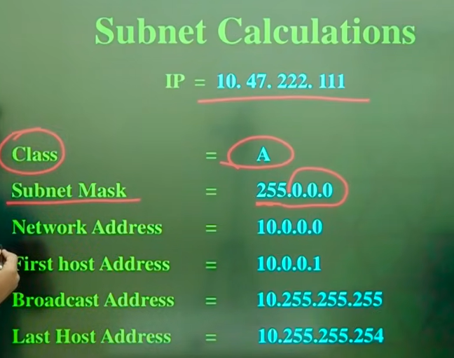

* **See the carefully and select class for it**
* **10 hi network address h**
* **1 is first host address**
* **Broadcast address is a address that comes after network address**
* **Last Host address is 255.255.255**
* **first host address is a default gateway**



* **How to compress IPv6 address**

**2601:04C3:4002:BE00:0000:0000:0000:0066**

**Remove Leading Zero**

**2601:4C3:4002:BE00:0:0:0:66**

**Group of Zero Double colons:: Leading Zeros are Optimal**

**2601:4C3:4002:BE00::66**

* **How to generate your own static private IPv6 address with MAC**
* **We make change in Host address**
* **Not in network address**
* **Add ff:fe between MAC**
* **Change second entity according to table of first pair**
* **Combine first two pair to make IP bcz it has 4 entities**

**BC:2d:aa:4b:98:a7 Be2d:aaff:fe4b:98:a7**

**Second entity change according to table**

**18:b4:30:10:7b:6 1 1Ab4:30ff:fe10:7b:61**

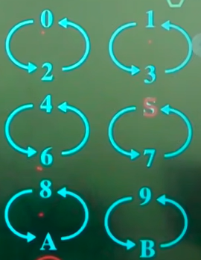

**C e**

**D f**

* **How IPv6 or IPv4 address assign you**
* **Entity**
* **IALA(Internet Assign Number Authority)**
* **RIR( Regional Internet Registries)**
* **ISP (Internet Service Provider)**

**First of all IALA assign first pair of IP to RIR of multiple country and then RIR has its own IP set like first pair send by IALA is 2600 and RIR own set is DDDD so 2600:DDDD and then it send to ISP ant also add one Pair of IP by itself that is 2600:DDDD:1111 this part called global routing prefix and we also known it by network address and its size is 48 bits.**

**2600:DDDD:1111:0001:0000:0000:0000:0001 Host Address size 48 bit**

**Locally assigned also known as subnet pair size 16 bit**



* **Tunneling means send data with another protocol.**
* **IPv6 developed gradually**
* **But still some system used IPv4**
* **To fill the difference between IPv6 and IPv4 tunneling used**
* **Example**
* Your mobile use IPv4
* But you want to access the website use IPv6
* Tunneling helps to envelop the IPv4 request into IPv6 and get the response from website and then send it to user in IPv4 Addreess
* Without tunnel IPv4 is not able to communicate with IPv6
* IPv4 traffic can be send to IPv6 network
* IPv6 traffic can be send to IPv4 network
* **TOOLS/softwares**

Some tools are used for that switching

**1.Teredo**

* Tunnel IPV6 through NATed IPv4
* End to End IPv4 through IPv6 network
* No special IPv6 router needed
* Temporary
* It automatically send data of IPv6 to IPv4

**2.Mirado**

* Open source Teredo for linux based on Unix and Mac
* Provide all functionality
* IPv 4 to IPv6
* IPv6 to IPv4



* NDP is a IPv6 system that help to find the other devices in a network
* IPv6 used NDP and IPv4 used ARP+extra features
* **IPv4**
* IP → MAC find by **ARP**
* **IPv6 :**
* No ARP used
* Use **NDP**



* ARP stand for Address resolution protocol
* It help to find the IP address of system through its MAC address
* Used in IPv4 network and switch IPv4 network to MAC address
* IP for routing
* MAC for Addressing

